**Trendline detection methods:**

1. **Moving average**

<https://www.investopedia.com/terms/e/ema.asp>

http://fbs.com/analytics/tips/how-you-may-use-the-emas-in-your-trading-15829

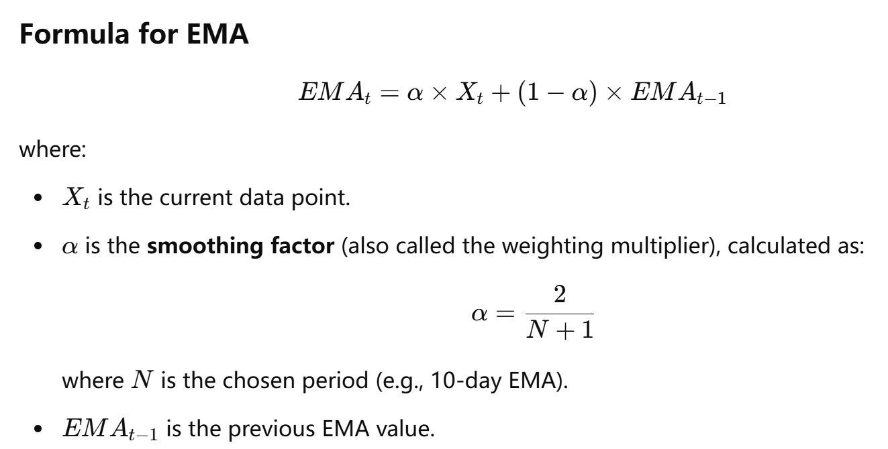

**Precision of the trendline detection:**

The precision here is when user choose different period(e.g. 10days, 20days) can significantly effect the trendline of the EMA, recall “*The 8- and the 20-day EMA tend to be the most popular periods for day traders, while the 50 and the 200-day EMA are better suited for long-term investors.*” There is no particular mathematical way to analyze the EMA period, trader usually us **ALL** famous period first on the **historical data** and then adjust it them by personal experience.

Note for the stock price data, the exponential moving average is perform well than the SMA. However this method is usually sensitive to the noise.

1. **Piecewise Linear regression**

<https://www.researchgate.net/publication/357932259_Piecewise_Linear_Regression>

basic idea:

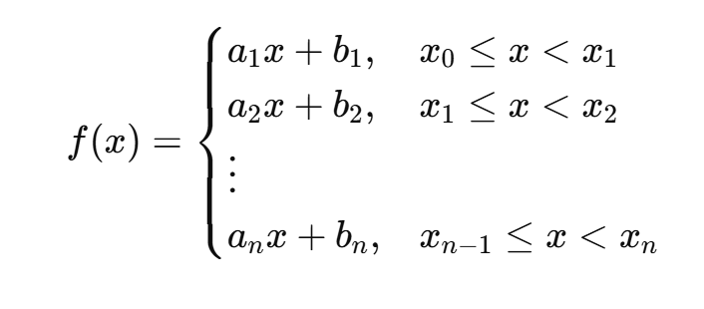

**Precision of the trendline detection:**

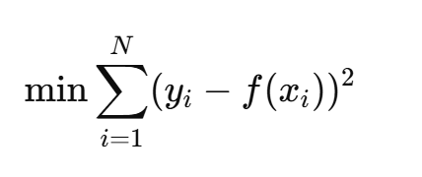 then the RSS is to find the optimal a1…an, b1…bn

Note: to work on any piecewise model we need to determine the breakpoint first. The recommend way is:

* 1. Binary Segmentation(FAST)

Splitting the data iteratively at points where the variance changes significantly.

* 1. Dynamic Programming(SLOW)

Minimizes the squared error while penalizing additional breakpoints.

1. **Fourier transformation**

<https://ieeexplore.ieee.org/document/7023581>

recall the Fourier and inverse Fourier transformation formula:

$\hat{g}(f) = \int{g(t)e^{-2πift}}dt$ $g\left(t\right)=\int{e^{2πifx}g(f) df}$

Thus the g_hat(f) show that at particular frequency of the stock data that can detected the noise.

**Precision of the trendline detection:**

Given the stock price data x(i) =1,2,n, its Fourier Transform can be denoted by g_hat(j),j=1,2,…m. And a new frequency transform we need to construct is represented by g_hat2(j),j=1,2,…,m. The method for constructing a new frequency transform is as follows:

if |g_hat(j)|>threshold then g_hat2(j)=g_hat(j)

if |g_hat(j)|<=threshold then g_hat2(j)=0

IMPORTANT NOTE here:

By the concept of the Fourier transformation, if the simply delete the noise, it will return the data that no longer related to time(some data_time will be droped). Thus intend of drop the noise, we can use some alternative value or simply zero out the outliers.

then use the inverse Fourier transformation on the new frequency data.

1. **Hough transformation**

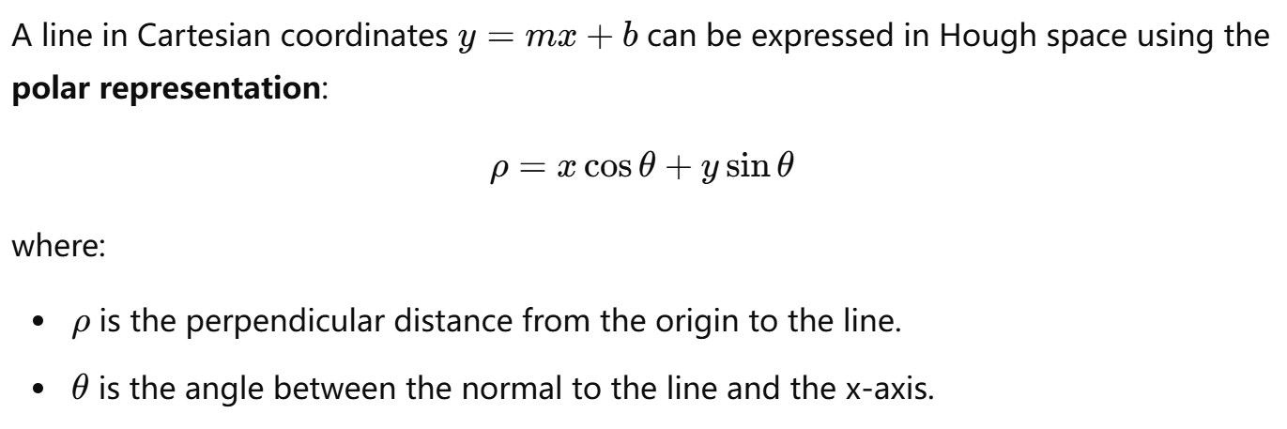

Thus the collection of points forming a linear trend will result in intersecting curves in the Hough space. The intersection points indicate the presence of strong linear trends.A discretized accumulator grid is used to store the number of votes each (ρ,θ)(\rho, \theta)(ρ,θ) pair receives. **The peaks in the accumulator space correspond to the most prominent trends** (i.e., the strongest linear patterns). The most significant trends (lines) are extracted by identifying the highest peaks in the Hough space These trends can represent **upward trends, downward trends, or periodic patterns** in time-series data